Romans in Britain – Vocabulary Page


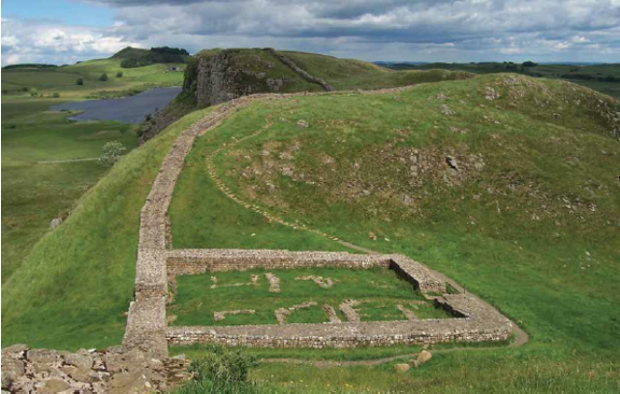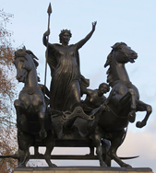

Tribe
Rebellion
Uprising
Architecture
Democracy
Colony
Republic
Social status
Emperor
Continuity

Resilience, Respect, Collaboration, Kindness, Integrity, Aspiration

