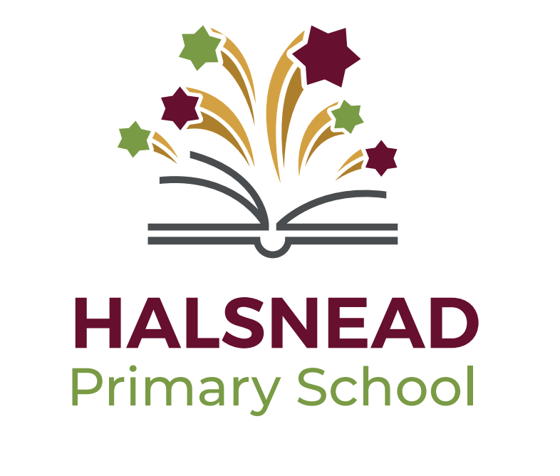

Cultural Capital at Halsnead Primary School

What is Cultural Capital?
Cultural capital is the accumulation of knowledge, behaviours, and skills that a child can draw upon and which demonstrates their cultural awareness, knowledge and competence; it is one of the key ingredients a child will draw upon to be successful in society, their career and the world of work.
Cultural capital promotes social mobility and success.
Cultural capital gives a child power. It helps them achieve goals, become successful, and rise up the social ladder without necessarily having wealth or financial capital.
Cultural capital is having assets that give children the desire to aspire and achieve social mobility whatever their starting point.

Policy Rationale
At Halsnead Primary School, we recognise that for children to aspire and be successful academically and in the wider areas of their lives, they need to be given rich and sustained opportunities to develop their cultural capital.
Our character curriculum is designed to give children a wide range of experiences where they can have the opportunity to apply their growing knowledge of value behaviours in a range of contexts.
Our cultural capital overview maps out weekly value behaviours, as well as knowledge of significant individuals and their achievements. Children focus on local, UK and World impact of these significant people. Through the character curriculum, children are given the opportunity to take part in projects to have their own impact on a local, UK and global level.

The school recognises that there are six key areas of development that are interrelated and cumulatively contribute to the sum of a child’s cultural capital:
- Personal Development
- Social Development, including political and current affairs awareness
- Physical Development
- Spiritual Development
- Moral Development
- Cultural development

Summary of the key areas of coverage for each area of Cultural Capital Development:

Personal development
- Citizenship, Personal, Social and Health Education provision;
- The school’s wider pastoral framework;
- Growth mindset support – resilience development strategies;
- Transition support;
- Work to develop confidence e.g. role play, supporting peers;
- Activities focused on building self-esteem;
- Mental Health & well-being provision.

Social Development
- Personal, Social and Health Education provision;
- Volunteering and charitable work – eg. raising funds for NSPCC and other charities;
- Pupil Voice – subject leadership pupil teams, pupil voice during subject impact time
- Pastoral support from all staff
- Mentor systems – every Year 6 child has an adult mentor, every Year 6 child mentors a younger child
- Reading buddies
- Maths champions
- Sport leaders

Physical Development
- The Physical Education curriculum;
- Healthy Eating policies and catering provision;
- Anti-bullying and safeguarding policies and strategies;
- The Health Education dimension of the PSHE programme, including strands on drugs, smoking and alcohol;
- The extra-curricular clubs related to sports and well-being;
- The celebration of sporting achievement including personal fitness and competitive sport;
- Activity-based residential visit for Year 5
- Design and Technology units related to food preparation and nutrition;
- Wellbeing part of PE curriculum

Spiritual Development
- The Religious Education Curriculum;
- Our collective acts of reflection;
- Support for the expression of individual faiths;
- Inter-faith and faith-specific activities and speakers
- Visits to religious buildings and centres;

Moral Development
- The Religious Education Curriculum;
- The PSHE curriculum
- The school’s Behaviour policy;
- Contributions to local, national and international charitable projects.
- Character curriculum projects

Cultural Development
- Citizenship education through PSHE;
- Arts education including Music and Drama;
- Access to the languages and cultures of other countries through the Geography and MFL curriculum;
- Promotion of racial equality and community cohesion
Each curriculum area makes its own contribution to children’s cultural capital development and supports SMSC across the school.

Cultural Capital Whole School Overview
Autumn 1
Autumn 1 | Week 1 | Week 2 | Week 3 | Week 4 | Week 5 | Week 6 | Week 7
Core Value Focus | Respect
British Value Focus | Mutual Respect
Value weekly theme/value behaviour | We listen to adults and respond in a respectful manner. We listen closely and attentively to others. | We show sensitivity and respect for others' feelings, cultures and beliefs, showing respect for diversity. | We speak to each other in a kind manner. | We follow instructions first time | We always display good manners. | We respect school property. We use our hands and feet kindly. | We recognise and celebrate the achievements of others.
Whole School Themed Days/Weeks | Anti-bullying – Police Visits  Fire Brigade visit  Cycling Proficiency  Road safety workshops  KABs workshops – self-esteem  Play leaders workshops  Electrical safety  Black History Month  Character Curriculum days x 2  Forest School Experiences
Cultural Capital – broadening experiences  Autumn 1 and Autumn 2  (Cycle dependent) | KS1 Visit - Changes in Britain – Victorian History – Trip to Tattenpark – Victorian School Day  KS1 Visit - Local Area walk  KS1 Visitor – Local Historian  KS1 Visit – St Nicolas Church  LKS2 Visit – Stone Age Experience – Liverpool Museum (including museum tour and Egypt floor)  LKS2 Visitor – Forces and Magnets – Science – Hands on Science  LKS2 Visit– Local history workshop – Prescott Museum  Lks2 Visit - Recycling discovery centre – Global Caretakers  UKS2 Visit – Romans in Britain – Chester workshop – Grosvenor museum Roman tour  UKS2 Visit – Salford Air Raid Shelters or Liverpool War Museum.  UKS2 Visit – Looking after our Landscape - Local area walk – map work  UKS2 Visitor – Animal Classification – Hands on Science
Cultural Capital Knowledge Theme | Significant People
Cultural Capital – broadening knowledge | Personal Aspiration  England Women’s Football Team | Global Impact  Barack Obama | Personal Aspiration  Serena Williams | Personal Aspiration  Malorie Blackman | Diversity Focus  Nelson Mandela | Moral Compass  Malala Yousafzai | Global Impact  David Attenborough

Autumn term 2
Autumn term 2 | Week 1 | Week 2 | Week 3 | Week 4 | Week 5 | Week 6 | Week 7
Core Value Focus | Resilience
British Value Focus | Individual Liberty
Value weekly theme/value behaviour | We hold positive views of ourselves and our own abilities | We can identify how we are feeling and use strategies to cope | We recognise that mistakes are part of learning | When we don't understand something we never give up: we try and try again | We persevere and keep going when things are hard | We approach new challenges with a problem solving attitude | We recognise our own strengths and build on these.
Whole School Themed Days/Weeks | Handwashing workshops  KABs workshops – confidence and teamwork  E-Safety talk – Police  Online bullying workshops  Firework Safety -Merseyside police  Anti-Bullying Week – Bully Busters  Children in Need  Importance of/maintaining personal hygiene – spread and control of diseases  Character Curriculum days x 2  Forest School Experiences
Cultural Capital – broadening experiences  Autumn 1 and Autumn 2  (Cycle Depenent) | KS1 Visit - Changes in Britain – Victorian History – Trip to Tattenpark – Victorian School Day  KS1 Visit - Local Area walk  KS1 Visitor – Local Historian  KS1 Visit – St Nicolas Church  LKS2 Visit – Stone Age Experience – Liverpool Museum (including museum tour and Egypt floor)  LKS2 Visitor – Forces and Magnets – Science – Hands on Science  LKS2 Visit– Local history workshop – Prescott Museum  Lks2 Visit - Recycling discovery centre – Global Caretakers  UKS2 Visit – Romans in Britain – Chester workshop – Grosvenor museum Roman tour  UKS2 Visit – Salford Air Raid Shelters or Liverpool War Museum.  UKS2 Visit – Looking after our Landscape - Local area walk – map work  UKS2 Visitor – Animal Classification – Hands on Science
Cultural Capital Knowledge Theme | Significant Achievements
Cultural Capital – broadening knowledge | Diversity Focus  Katherine Johnson | Local Impact  Andy Grant (Liverpool) | Diversity Focus  Maya Angelou | Diversity Focus  Helen Keller | Personal Aspiration  Edmund Hillary | Personal Aspiration  Thomas Edison | Personal Aspiration  Mo Farah

Spring term 1
Spring term 1 | Week 1 | Week 2 | Week 3 | Week 4 | Week 5 | Week 6
Core Value Focus | Integrity
British Value Focus | Rule of Law; Democracy
Value weekly theme/value behaviour | We are role models to others. | We tell the truth | We treat everyone well | We choose to do the right thing. We encourage others to do the right thing. | We take responsibility for our own actions | We say sorry when we make a mistake. We forgive people and don't hold grudges.
Whole School Themed Days/Weeks | GANGs Man Visit  Financial Education  Fire brigade visit  KABs workshops  Safer Internet Day  NSPCC Workshops  Safer Internet Day  Human Rights Week – United Nations Declaration of the Rights of a Child  Character Curriculum days x 2  Forest School Experiences
Cultural Capital – broadening experiences  Spring term 1 and Spring term 2  (Cycle Dependent) | KS1 Visit – Synagogue  KS1 Visit – Local area walk (comparison)  KS1 Visit – Animals and their Needs. Knowsley Safari Park  LKS2 Visit – Hindu temple  LKS2 Visit - Library Visit  LKS2 Visitor – States of Matter – Hands on Science  LKS2 Visit – Buddhist Temple  UKS2 Visit – Mosque (Islam)  UKS2 Visit – Earth and Space – Jodrell Bank  UKS2 Visit – Rivers – Loggerheads River Study Colomendy
Cultural Capital Knowledge Theme | Significant Events
Cultural Capital – broadening knowledge | Diversity Focus  John Archer | Global Impact  Mohammad Ali | Moral Compass  William Roscoe | Diversity Focus  Tanni Grey Thompson | Moral Compass  Greta Thunberg | Local Impact  Heros of the Community

Spring term 2
Spring term 2 | Week 1 | Week 2 | Week 3 | Week 4 | Week 5 | Week 6
Core Value Focus | Kindness
British Value Focus | Tolerance
Value weekly theme/value behaviour | We are role models and lead by example, showing others what being kind looks like. | We notice kindness and recognise and give praise when we notice others being kind and supportive to one another. | We treat people how we expect to be treated. | We share with others. | We encourage people by saying positive things. We don't say unkind things to others. | When people make mistakes we forgive them and don't hold grudges.
Whole School Themed Days/Weeks | My Money Week  Red Nose Day Fundraiser  Dogs’ Trust  Yoga and Mindfulness day  Responding in an emergency – at home and in school.  First Aid day  Character Curriculum days x2  Forest School Experiences
Cultural Capital – broadening experiences  Spring term 1 and Spring term 2  (Cycle Dependent) | KS1 Visit – Synagogue  KS1 Visit – Local area walk (comparison)  KS1 Visit – Animals and their Needs. Knowsley Safari Park  LKS2 Visit – Hindu temple  LKS2 Visit - Library Visit  LKS2 Visitor – States of Matter – Hands on Science  LKS2 Visit – Buddhist Temple  UKS2 Visit – Mosque (Islam)  UKS2 Visit – Earth and Space – Jodrell Bank  UKS2 Visit – Rivers – Loggerheads River Study Colomendy
Cultural Capital Knowledge Theme | Significant Legacy
Cultural Capital – broadening knowledge | Diversity Focus | Local Impact  Noel Chavasse | Local Impact  Heros of the Community | Global Impact  Dr Barnardo | UK Impact  Florence Nightingale | UK Impact  Marie Curie

Summer Term 1
Summer Term 1 | Week 1 | Week 2 | Week 3 | Week 4 | Week 5
Core Value Focus | Collaboration
British Value Focus | Democracy; Tolerance; Mutual Respect
Value weekly theme/value behaviour | We work well in a group and encourage each other. | We listen to what everyone has to say with respect and interest. | We get on with everyone in our class. | We say encouraging words to each other. | We recognise each other’s strengths.
Whole School Themed Days/Weeks | Rail Safety  Walk to School Week  NSPCC – PANTS  Bikeability  Crucial Crew day  Dental health and healthy eating  Forest School Experiences  Character Curriculum year group projects
Cultural Capital – broadening experiences  Summer term 1 and Summer term 2  (Cycle dependent) | KS1 Visit - Holidays from the Past – Trip to Southport beach  KS1 Visitor – Animal experience  KS1 Visit – Liverpool Maritime Museum – Titanic workshop.  KS1 Visit - Ferry across the Mersey experience  KS1 Visit – Hill walk – Moel Famau  LKS2 Visit – Rural area walk. Village in Chesire. Burwardsley (including visit to farm)  LKS2 Visit – Ancient Egypt - Liverpool World Museum  UKS2 Residential Trip – 2 nights  UKS2 Visit – Geography local area walk (comparison)  UKS2 Visit – Liverpool Cathedral
Cultural Capital Knowledge Theme | Significant Teams
Cultural Capital – broadening knowledge | Personal Aspiration  New Zealand All Blacks | UK Impact  Suffragettes | Global Impact  Apollo 11 | Global Impact  Ernest Shackleton | Diversity Focus  Kelly Marie Gallagher

Summer Term 2
Summer Term 2 | Week 1 | Week 2 | Week 3 | Week 4 | Week 5 | Week 6
Core Value Focus | Aspiration
British Value Focus | British Values Overview
Value weekly theme/value behaviour | We know our aspirations for the future | We aim high in everything we do | We push ourselves in our learning to try and always try our best. | We set ourselves high targets and aim to reach these. | We read often and know the importance of reading. | We reflect on our own learning and think about how we can improve.
Whole School Themed Days/Weeks | Healthy Eating Week  Water Safety  NSPCC – Making Sense of Relationships  Transition  Enterprise Project  Well-Being Week – physical, emotional, mental health  Aspirations Day  Water Safety  Whole School Fundraiser  Forest School experiences  Character curriculum year group projects
Cultural Capital – broadening experiences  Summer term 1 and Summer term 2  (Cycle Dependent) | KS1 Visit - Holidays from the Past – Trip to Southport beach  KS1 Visitor – Animal experience  KS1 Visit – Liverpool Maritime Museum – Titanic workshop.  KS1 Visit - Ferry across the Mersey experience  KS1 Visit – Hill walk – Moel Famau  LKS2 Visit – Rural area walk. Village in Chesire. Burwardsley (including visit to farm)  LKS2 Visit – Ancient Egypt - Liverpool World Museum  UKS2 Residential Trip – 2 nights  UKS2 Visit – Geography local area walk (comparison)  UKS2 Visit – Liverpool Cathedral
Cultural Capital Knowledge Theme | Significant Dreams
Cultural Capital – broadening knowledge | Diversity Focus  Michelle Obama | Local Impact  Katarina Johnson-Thompson | Global Impact  Henry Ford | UK Impact  William Shakespeare | Personal Aspiration  Year 6 | Personal Aspiration  Year 6

