

Evaluate Your Learning
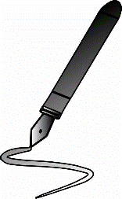
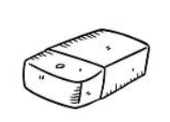
Presentation
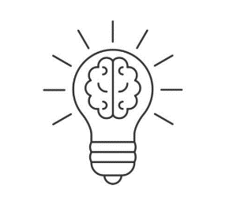
Accuracy
Understanding
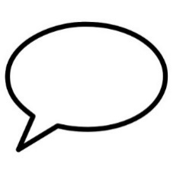
Language

5 – My very best/Wow! I can explain it to someone else
4 – Very nearly my best/I’m nearly there
3 – I could do better/I’m starting to understand
2 – I must try harder/I need more help
1 – I didn’t try/I don’t get it

