

Halsnead Non-Core Teaching Approach

The Halsnead teaching approach is a structure that supports the retention and application of knowledge and vocabulary. It can be remembered through the acronym SMARTER.

The SMARTER lesson approach
Start with retention
Map it
Ask a big question
Read the objective
Today’s knowledge and vocabulary
Engage in learning
Retention and application tasks
Reflection

- Retention    Activating prior knowledge | Systematic Knowledge Retention  Start the lesson with a low stakes knowledge retrieval quiz – Last lesson, current topic, previous topic, previous year group.  This could be teacher led, child led, using knowledge planners, retention grids, book check backs and other school strategies.  Knowledge retention is systematic and needs to focus on pre-requisite knowledge around key concepts covered in the lesson.
- Mind Map  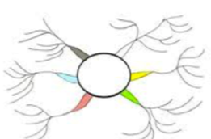  Activating prior knowledge | Map out concept knowledge  Pull together all previous learning by adding to an ongoing mind map around concept knowledge.  Teacher led or independent.  Model thinking out loud and making knowledge links to build schema.  Children work on mind maps in books and model on working walls.
- Big Question    Activating prior knowledge | Engage children in thinking about concept knowledge  Ask a big question that is linked to today’s new learning. Focus on the concept being taught.  Assess any prior knowledge. Hook children into learning. Provide an opportunity to link back to any prior knowledge children can use and apply.  Example – How can invasions have a long term impact on a nation?
  - Lesson Aims  Explicit Strategy Instruction | Read and clarify lesson aims  How does this fit into the big picture of learning? Strategy: Zoom out, Zoom in.  Key Takeaway – remind children they will be sharing key takeaways at the end of the lesson.
- Knowledge and Vocabulary    Explicit Strategy Instruction  Memorisation of strategy | Key knowledge – substantive and disciplinary  Introduce all knowledge and vocabulary children will be learning. Spend time remembering and learning. Use of mnemonics where appropriate. Vocabulary taught in context.  Display vocabulary throughout lesson. Encourage children to use in context.
- Engage    Explicit Strategy Instruction  Modelling of learned strategy  Guided Practice  Independent Practice | Engage children in thinking about key substantive and disciplinary knowledge  I do  Explicit teaching of concept knowledge in context. Memorisation and schema building. Knowledge links made explicit.  Explicit teaching of disciplinary knowledge. Modelling of disciplinary knowledge. How do historians interpret sources? How do scientists classify?  We do  Guided practice of disciplinary knowledge.  You do  Independent practice opportunities
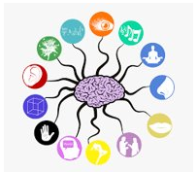  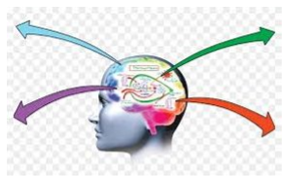  - Retention/Application Tasks  Independent Practice | Independent practice linked to knowledge outcomes  Independent lesson task(s) that gives an opportunity for children to show what knowledge they have retained, or an opportunity to apply their knowledge. Knowledge application tasks come later in units of work.  Pupil voice essential in tasks. Feedback given is related to knowledge and vocabulary relevant to the lesson, and how children meet the objective.
- Reflection    Structure self reflection | Children monitor and evaluate own learning  Use of Key Takeaway  Whole Class Feedback  P.A.U.L reflection  Self-reflection questions

