



Long Term Memory Techniques
Acronyms and Acrostics  Can you use the initial letters of each word?    North South East West  Never Eat Shredded Wheat | Association  Can you link your knowledge to something else to help you remember?  Liverpool’s first dock - 1715  (Quarter past 5!)   | Explain it/Teach it  Can you teach or explain the idea to a friend?  
Use a Story  Can you put your knowledge into a story to help you remember?   | Graphic Organisers  Can you put your knowledge into a diagram, chart or mind map to help you remember?  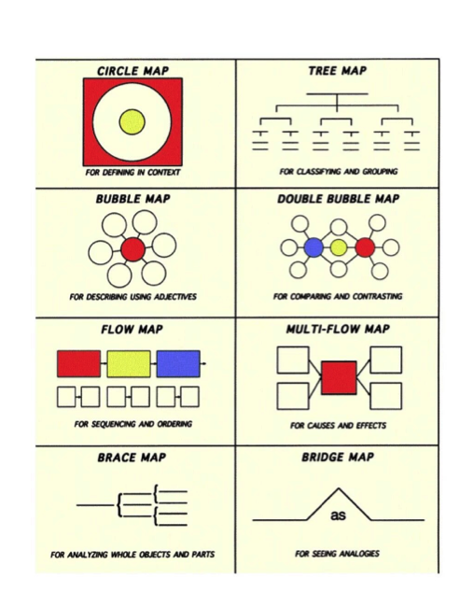 | Music and Rhyme  Can you create a song or rhyme to help you remember?  
Active Learning  Can you put some actions to your knowledge to help you remember?   | Images  Can you draw simple images to represent facts? Then try to remember what fact the image represents!   | Chunking  Can you put your ideas into groups to help you remember?  
Spatial Systems  Can you put each fact on a different body part to help you remember it?  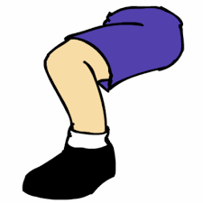  E.G. South America is on your foot, North America is on your knee! | Roman Room  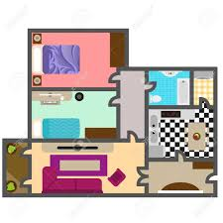  Place each fact you need to learn inside a room of your house. Imagine seeing these facts as you walk around your house from room to room. Which fact will open the door? Which fact will be sitting in the living room? This ancient memory technique has been used for thousands of years! | Retrieval/Retention Quiz    Regularly quiz yourself on your knowledge. Practise over and over again and It will stick. Can you create your own quiz questions to test yourself?

