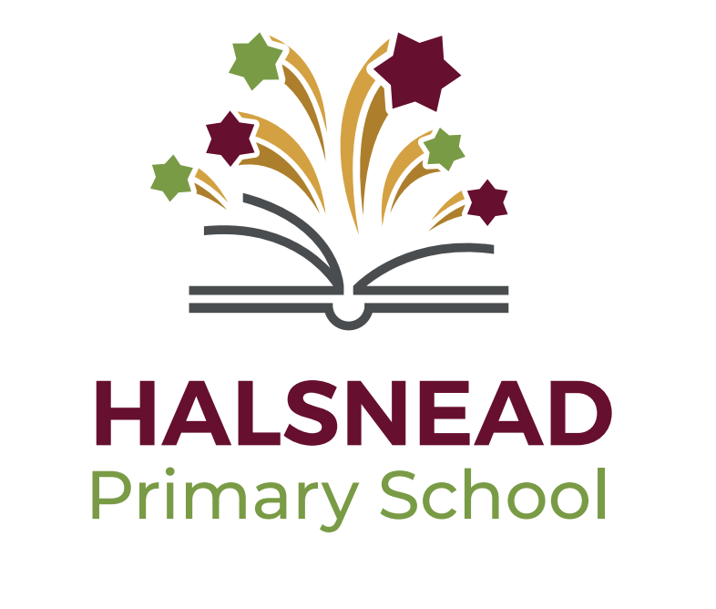


Halsnead Character Curriculum 2022

Intent

Halsnead’s character curriculum will provide opportunities for children to develop characteristics, values and life skills that will equip them in the future and enable them to reach their personal excellence. Our curriculum maps out a range of experiences and opportunities for children to develop key life skills that will empower them to achieve their aspirations. We want our pupils to believe in themselves, to have ambition and be the best they can be.

The programme actively seeks to promote a self-belief that if you have high aspirations for your future, with work hard and resilience you can succeed.

The start of each academic year involves an Aspirations session with children. Children will talk about their future aspirations and fill out an aspiration profile which they will add to and edit throughout their time at Halsnead. Children will reflect on themselves and create an aspiration statement. Once children reach UKS2, they will write these aspiration statements in the past tense, to encourage them to reflect on what their impact could be on other people and the world:

KS1 example:
I want to be a vet because I love dogs and like to help animals.

LKS2 example:
I aspire to be a teacher because I like to learn and want to help inspire others to reach their potential.

UKS2 example:
She was an inspirational doctor , who helped save the lives of patients through her passion for people and her ability to stay calm in all situations.

He was an intelligent mathematician, who dedicated his time to improving large businesses across the world through his passion for maths and his ability to solve complex problems with ease.

Values for Life

Our character curriculum aims to give children further opportunity to learn about our school values and how these values are important in shaping your future.

- Aspiration
- Resilience
- Kindness
- Respect
- Collaboration
- Integrity

Our values feature throughout all aspects of the curriculum, as well as having specific value sessions throughout.

Projects

Each year children will work alongside other children in their year group to complete an impact project. Children will have the opportunity to plan and carry out a project that has a positive impact on others. Projects will run over the final term and will be a chance for children to apply what they have learned/developed over the year.

Year 1 – School impact project

Value focus: Collaboration

Children will learn about the importance of collaboration.
They will work together to plan a project that positively impacts on the whole school community.
Children will have the chance to present their project to children and parents in an assembly.
They will reflect on the value ‘collaboration’ and how they have shown the value behaviours throughout the project.

Example project ideas:

Outdoor reading initiative
Running a Healthy living week
A project to improve our playground and playtime
Organising a whole school picnic
Organising a reading week

Year 2 – Community impact project

Value focus: Respect

Children will learn about the importance of respect. They will learn to value and respect all parts of our local community and understand the important role they play now and in the future of our community.
They will work together to plan a project that positively impacts on our local community.
Children will meet with a range of different people from our community who may be impacted by the project, including local councillors and local residents.
Children will have the chance to present their project to children and parents in an assembly.
They will reflect on the value ‘respect’ and how they have shown the value behaviours throughout the project.

Example project ideas:

Improving the area around school
Supporting a local nursing home
Linking with local community groups to do a joint project
Inviting local community groups to allotment sessions
Working alongside Willowbrook in a fund raising project

Year 3 – UK impact project - charity

Value focus: Kindness

Children will learn about the importance of kindness. They will learn about the importance of charity in the UK and will work together to plan a fund raising initiative for a UK charity.
Children will meet with charity representatives and share their fund raising ideas.
Children will have the chance to present their project to children and parents in an assembly.
They will reflect on the value ‘kindness’ and how they have shown the value behaviours throughout the project.

Example project ideas:

Raising money for a UK charity through class fundraising projects over the course of the year

Year 4 – World impact project

Value focus: Integrity

Children will learn about the importance of Integrity. They will explore world issues that affect our planet now and in the future.
Children will learn about inspirational world figures who have initiated change and made a difference.
They will work together to plan a project that positively impacts on our World.
Children will write to local, national and international people who are currently tying to make a positive impact on our planet.
Children will have the chance to present their project to children and parents in an assembly.
They will reflect on the value ‘integrity’ and how they have shown the value behaviours throughout the project.

Example project ideas:

Raising awareness of climate change
Tackling plastic pollution to make a difference
An ocean clean-up project, working alongside national trust Formby Beach
A project to improve local energy use across the school community
A campaign for national school energy saving days across the country

Year 5 – Personal impact project - aspiration

Value focus: Aspiration

Children will learn about the importance of aspiration.
They will revisit their aspiration statements and meet with people who can talk to them about their aspirations.
They will look ahead to their future and research and experience different career options and ways to achieve this.
They will visit a University and learn about degrees.
They will visit Jaguar Landrover factory and learn about apprenticeships.
They will interview people from a range of different careers during a careers day.
Children will have the chance to present their project to children and parents in an assembly.
They will reflect on the value ‘aspiration’ and how they have shown the value behaviours throughout the project.

Example project ideas:

Explore a range of different future careers and the journey needed to achieve.
Interview adults from a range of careers.
Visit a University.
Visit Jaguar Landrover and have a factory tour day, learning about apprenticeships.
Review and refine aspirations statements.

Year 6 – Enterprise impact project

Value focus: Resilience

Children will learn about the importance of resilience.
They will learn about enterprise and business around the world.
They will plan their own enterprise project in groups.
Children will receive £30 investment from school which will need to be paid back.
They will use this money to create an enterprise business to raise money.
Children will then use the money they have raised to invest in a real life 3rd world country business through the charity website: LendWithCare.org

Example project ideas:

Enterprise projects such as:
Water bottle sales
Stationary sales
Exercise classes
Sports classes
Healthy snack stalls
Sports equipment
Toy shop
Sticker shop

This project will also incorporate a whole class enterprise project: Growing and selling healthy food (working alongside Lets Localise through the Green Bronx Machine project).

Year 6 Half Termly Assemblies

Each half term, Year 6 children will run a whole school assembly focussing on character curriculum. They will be supported by planning material and PowerPoint presentations. They will develop their confidence, resilience and public speaking skills.

Character Curriculum Afternoons

Twice each half term, the whole school will take part in a character curriculum afternoon. This will be based on our half term value and will incorporate time for classes to engage in projects (during Summer 1).
Each session will focus on a text and will follow the planning structure outlined below:

Share key text and bring to life:
Big Questions of the day:
Initial response time:
Practical experience/challenge:
Explore the value (including examples in real life):
Review responses to questions:
Target and goal setting:

Value Behaviours

Children will be explicitly taught about our value behaviours. Each week the whole school will focus on one value behaviour and spend the week reflect on this in action. Teacher will promote, model and teach these behaviours throughout our character curriculum and our academic curriculum.

Collaboration

We work well in a group and encourage each other.

We listen to what everyone has to say with respect and interest.

We get on with everyone in our class.

We say encouraging words to each other.

We recognise each other’s strengths.

We cooperate and support everyone in our class.

Respect

We show sensitivity and respect for others’ feelings, cultures and beliefs, showing respect for diversity.

We recognise and celebrate the achievements of others.

We listen closely and attentively to others.

We speak to each other in a kind manner.

We use our hands and feet kindly.

We listen to adults and respond in a respectful manner.

We respect school property.

We follow instructions first time.

We always display good manners

Kindness

We are role models and lead by example, showing others what being kind looks like.

We notice kindness and recognise and give praise when we notice others being kind and supportive to one another.

We treat other people how we would expect to be treated.

We share with others.

We encourage people by saying positive things.

We offer to help others when they need it.

We don’t say unkind things to others.

When people make mistakes, we forgive them and don’t hold grudges.

Resilience

We hold positive views of ourselves and our own abilities.

We can identify how we are feeling and use strategies to help us cope.

We approach new challenges with a problem solving attitude.

When we don’t understand something we never give up. We try and try again.

We recognise our own strengths and build on these.

We recognise that mistakes are part of learning.

We enjoy a challenge and approach hard work with a positive attitude.

We persevere and keep going when things are hard.

We review, edit and retry work with a positive attitude.

Integrity

We act in a fair, honest and responsible way.

We tell the truth.

We treat everyone well.

We choose to do the right thing.

We take responsibility for our own actions.

We say sorry when we have made a mistake.

We forgive people and don’t hold grudges.

We challenge inappropriate behaviour.

We are role models to other children.

We encourage others to do the right thing.

Aspiration

We know our aspiration for the future.

We aim high in everything we do.

We push ourselves in our learning to try and always try our best.

We set ourselves high targets and aim to reach these.

We read often and know the importance of reading.

We reflect on our own learning and think about how we can improve.

Halsnead Character Building Experiences

By the end of your time at our school, you will have experienced each one of these special opportunities. Each will help you to reach your own personal and academic excellence.

By the end of KS1

Aspiration
- I will listen to lots of different people talking about their careers during Aspirations Day
- I will watch a live theatre play

Kindness
- I will raise money for a charity with my class
- I will cook a meal for someone

Integrity
- I will make a home for wildlife
- I will help a plant grow
- I will help a wild animal

Respect
- I will go on a local area walk and spot all of the good things about our local area
- I will watch lots of different birds
- I will keep a nature diary
- I will explore the wonders of a rock pool
- I will discover what’s in a pond
- I will go cloud watching

Collaboration
- I will complete a project to improve our school
- I will work together with my class to perform a play in front of the school
- I will take a friend on a nature adventure
- I will play on the beach with my friends

Resilience
- I will find my way using a map

By the end of Lower KS2

Aspiration
- I will visit a library
- I will write and perform a poem
- I will read out loud in front of the school

Kindness
- I will read to a younger child

Integrity
- I will write to a local councillor
- I will do something good for my local community
- I will do something to help the local environment

Respect
- I will bring up a butterfly
- I will forage for fungi
- I will visit different places of worship

Collaboration
- I will toast a marshmallow with my friends around a campfire
- I will write to someone from another country

Resilience
- I will conquer an orienteering course
- I will climb a huge hill

By the end of Upper KS2

Aspiration
- I will interview people from different careers during Aspirations day
- I will visit a University

Kindness
- I will be an entrepreneur and create a business to raise money for others
- I will mentor a younger child in Reception
- I will read a story to a class

Integrity
- I will take action to help prevent climate change

Respect
- I will watch the sunset on a residential trip
- I will go on a nature walk at night
- I will go stargazing
- I will experience awe and wonder in a cathedral
- I will eat a meal at a nice restaurant and demonstrate good table manners

Collaboration
- I will work together with a group of friends to teach children in a lower year group
- I will perform in a production in front of our whole school community
- I will toast a marshmallow with my friends around a campfire at night
- I will float in a boat
- I will play a musical instrument in a band

Resilience
- I will climb over rocks and boulders
- I will explore a cave
- I will climb a mountain

Halsnead Character Building Educational Enrichment

Key Stage 1 Visits and Enrichment

Visit – Theatre – Christmas Pantomime

Visit - Changes in Britain – Victorian History – Trip to Tattenpark – Victorian School Day

Visit - Local Area walk

Visit – place of worship – St Nicolas’ Church

Visit – place of worship – Synagogue

Visit – Local area walk

Visit –Knowsley Safari Park

Visit - Trip to Southport beach

Visitor – Hands on Science - Animal experience

Visit – Liverpool Maritime Museum – Titanic workshop.

Visit - Ferry across the Mersey experience

Lower Key Stage 2 Visits and Enrichment

Visit – Liverpool Library

Visit – Stone Age Experience – Liverpool Museum

Visitor – Forces and Magnets – Science – Hands on Science

Visit– Local history workshop – Prescott museum

Visit - Recycling discovery centre – Global Caretakers

Visit – place of worship – Buddhist Temple

Visitor – States of Matter – Hands on Science

Visit – Rural and Urban area walk – Burwardsley Village – Chesire (including hill climb at Peckforton Castle and visit to farm).

Visit – place of worship – Islam – Mosque

Upper Key Stage 2 Visits and Enrichment

Visit – Romans in Britain – Chester

Visit – Earth and Space – Jodrell Bank

Visit – Salford Air Raid Shelters or Liverpool War Museum.

Visit – Looking after our Landscape - Local area walk – map work

Visitor – Animal Classification – Hands on Science

Visit – Earth and Space – Jodrell Bank

Visit – Rivers – Loggerheads River Study Colomendy

Visitor – BAME history topic – local Liverpool historian

Visit – place of worship – Hindu temple

Residential Trip – 2 nights – Ghyll Head Lake District

Visit – place of worship – Liverpool Cathedral

End of year Experiences
At the end of each year, children will take part in a character curriculum celebration at a special place. This will be a chance to celebrate the achievements of the year and reflect on aspirations.
KS1 – Beach
KS1 – Hill
LKS2 – Forest
LKS2 – River
UKS2 – Lake
UKS2 – Mountain

